- Create VPC with 1 private and 1 public subnets.
- Go to aws console log in
- Search vpc and go to vpc (virtual private cloud)
- Create vpc give the name and select the cidr range from <ipadress>/16 to /28
- After creating go to the create subnets create one subnet and private subnet by providing the cidr block range according to the cidr range
- The private and public subnets are created
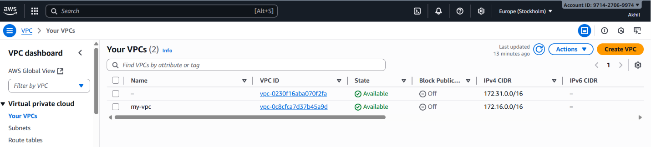
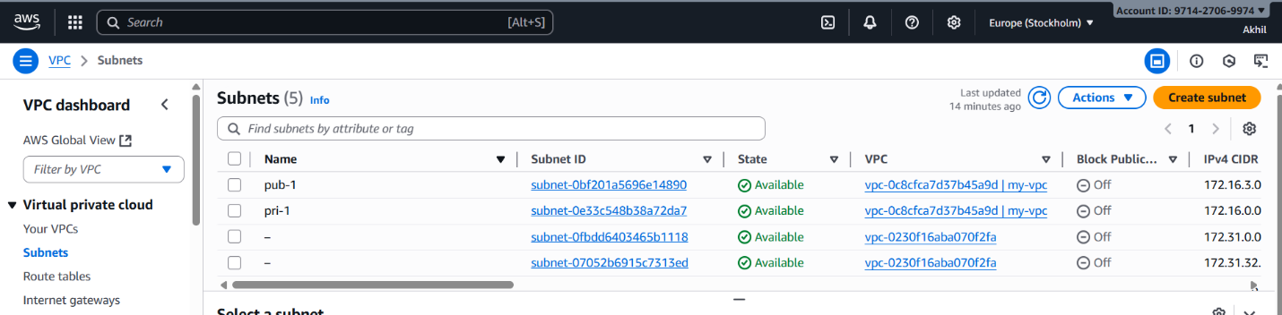
2.Enable VPC peering for cross-region
- Navigate to peering connections and create peering connection
- Give connection name
- Note: - for this you need to create two vpc in two different region
- Select your vpc to which you are providing the opeering connection
- Select the vpc to connect from one region to other
- Provide the vpc id you want to connect
- The request to the other region from one region is sent, accept the request the peering connection is set

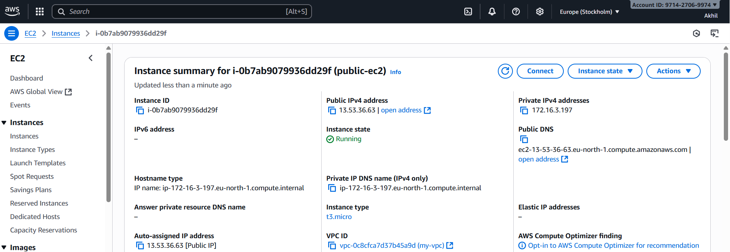
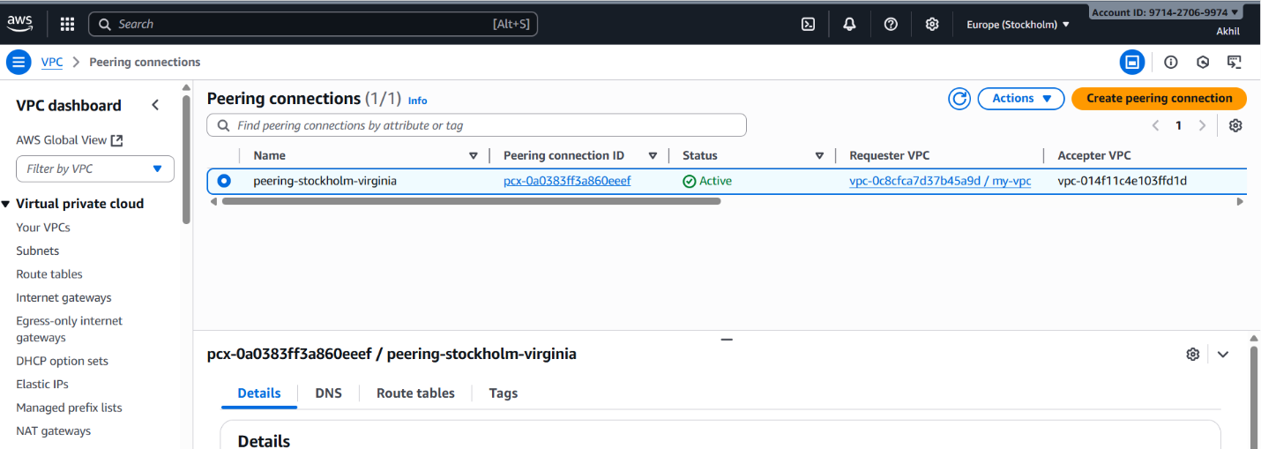
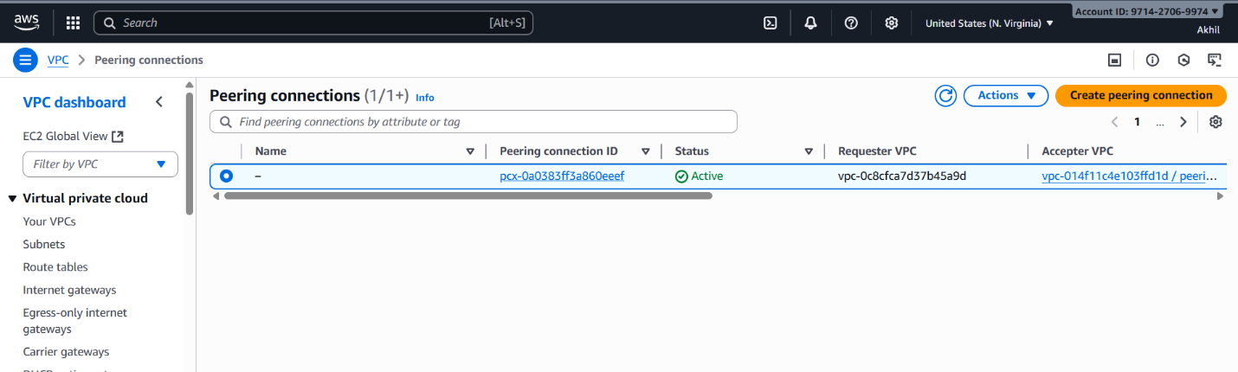
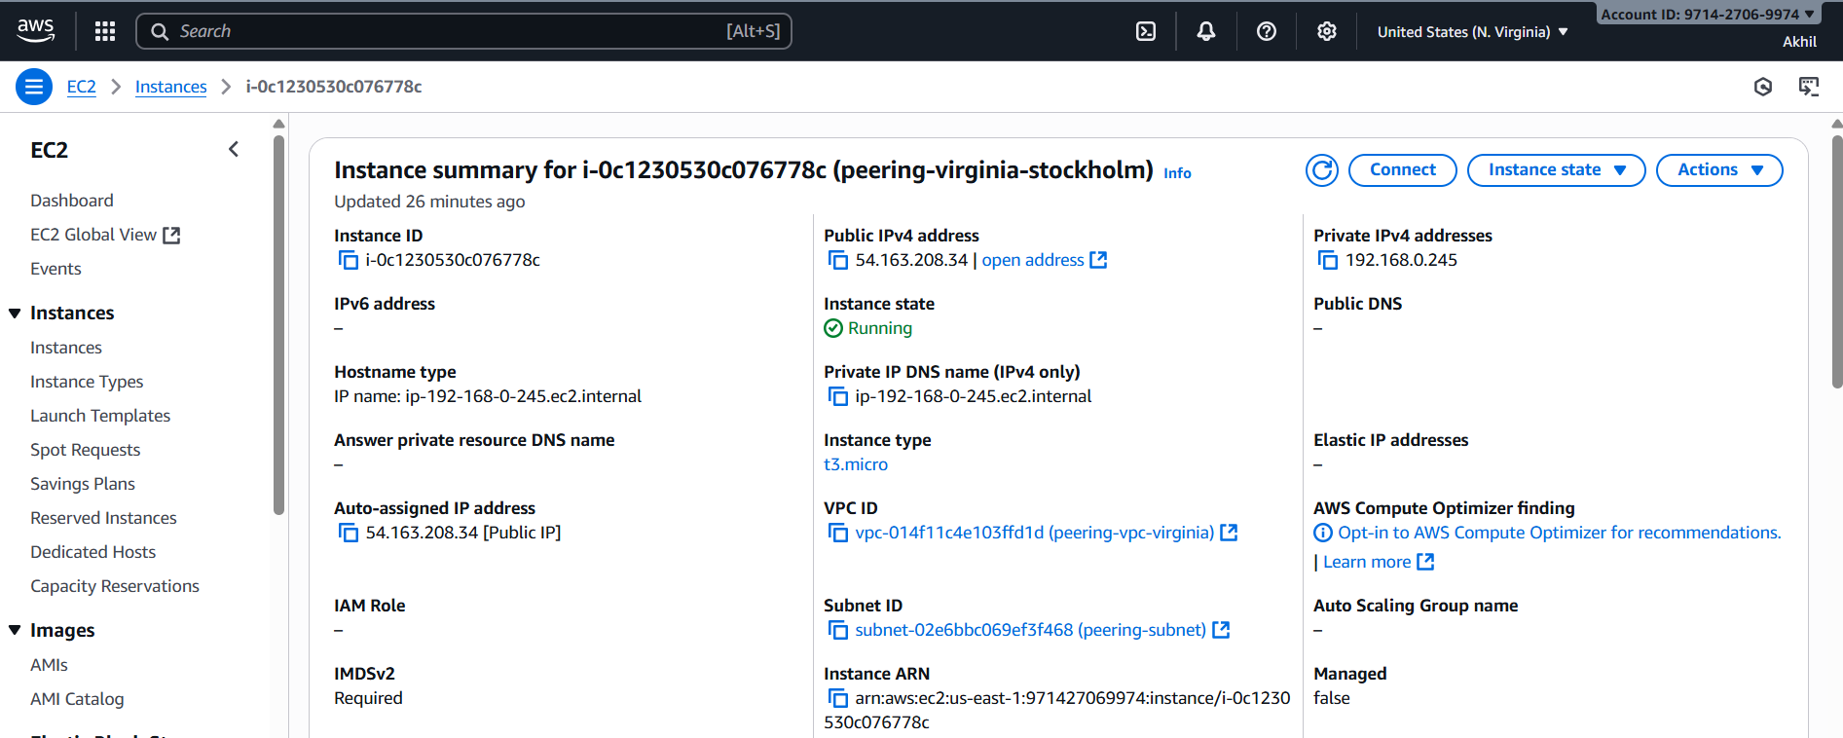
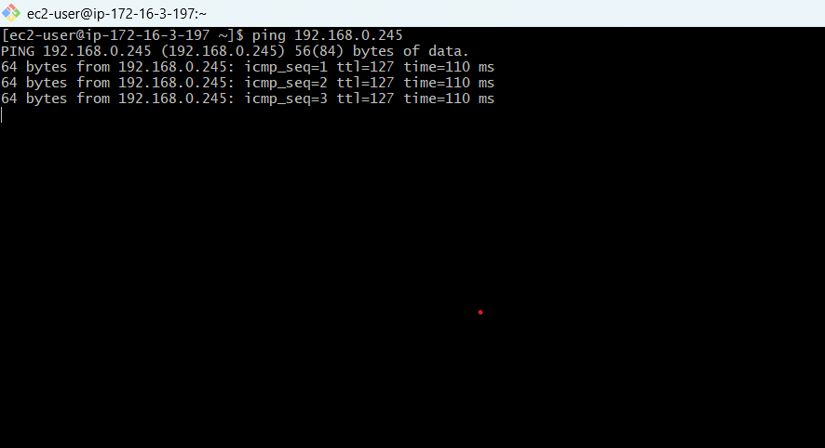
3.Enable VPC peering for cross-account.
- For this follow the similar steps for peering cross region
- Change the peering to another account and and give the account id of the other user
- Also provide the vpc id to send the peering request from one account to the other account user
- The account accept the peering request the peering connection is set.

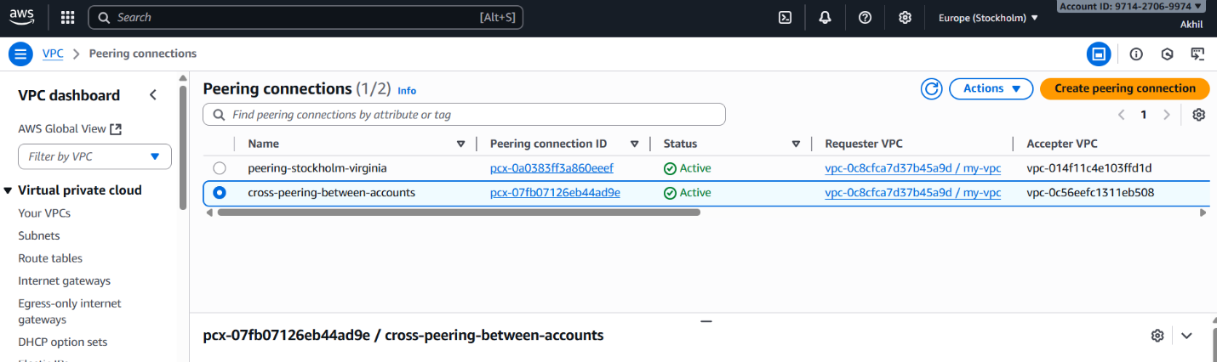

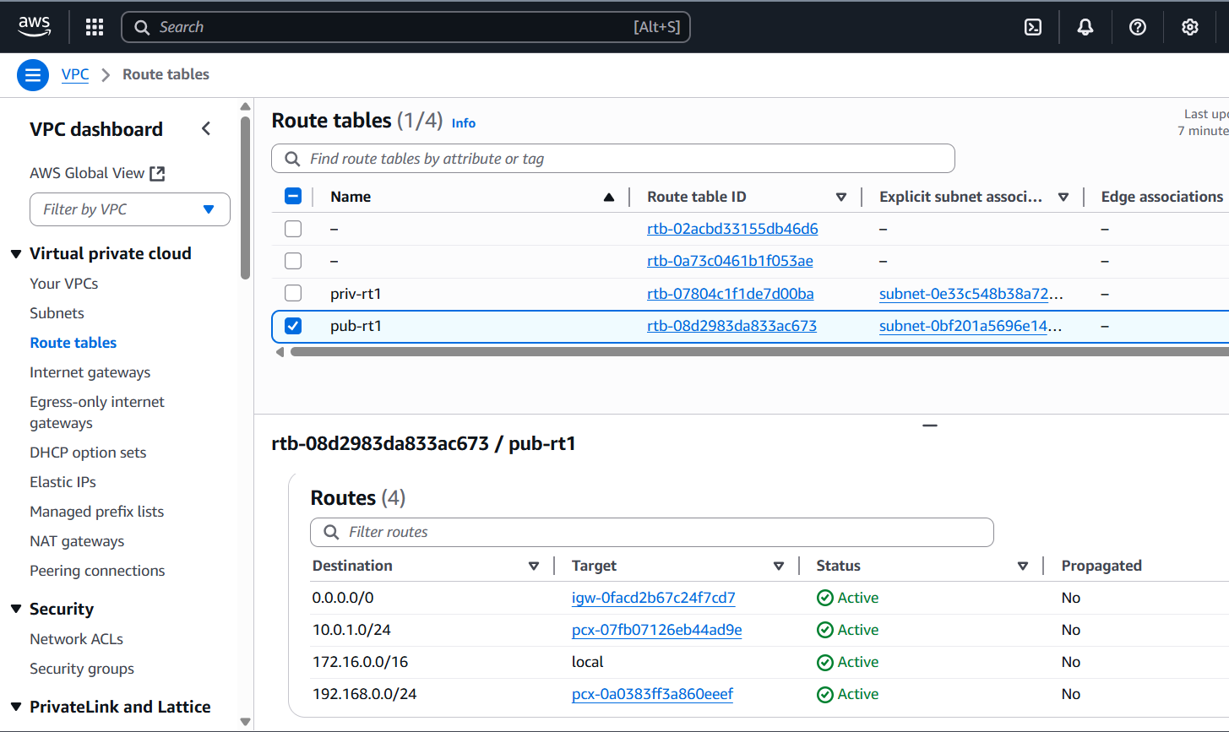
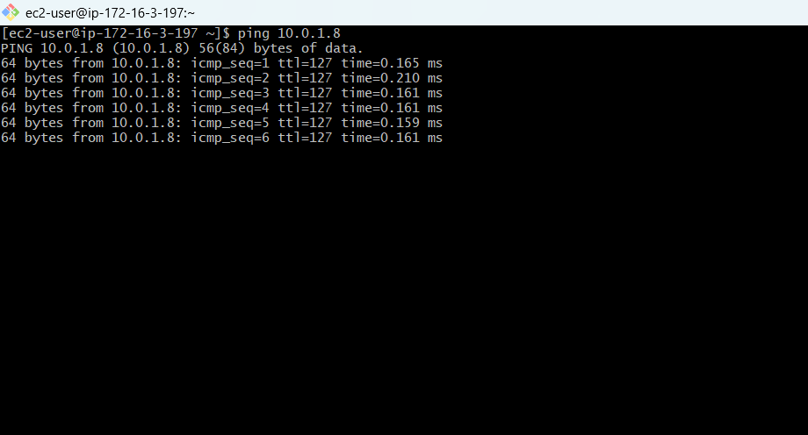
4.Set up a VPC Transit Gateway
- Create three vpc with one for public and two for the private
1) 172.168.0.0/24
Cidr range of 3 vpc’s created
2)10.0.1.0/28
3) 10.0.0.0/28
- Create the subnets to the vpc’s created
- Go to transit gate way create one transit gateway
- Then create transit gateway atachments to the vpc’s
- Then launch three instances with three vpc’s
- No connect to the vpc 1 with the public ip in CLI i.e git bash
- Then ping the private ip of the other two instances
- Attach the transit gateway to the public vpc of two other vpc cidr range created so that whwever try to connect to the vpc try to send to particular transit gateway.
- Do the same to the other vpc attach the vpc cidr range of other vpc –target transit gateway
- Create IGW (internet gate way and for vpc and attach to the routes
- If it not connecting go to ec2 – security group – add port no all traffic –then you can see coneection is established to private ec 2 created in CLI
- Use: ping <ip address private>

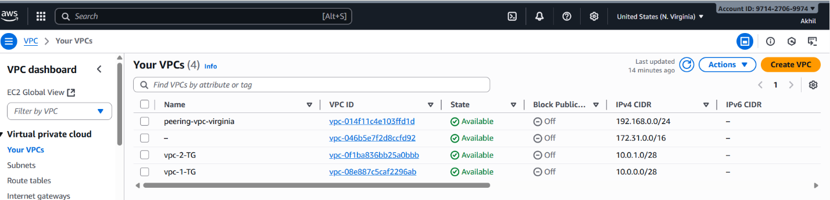
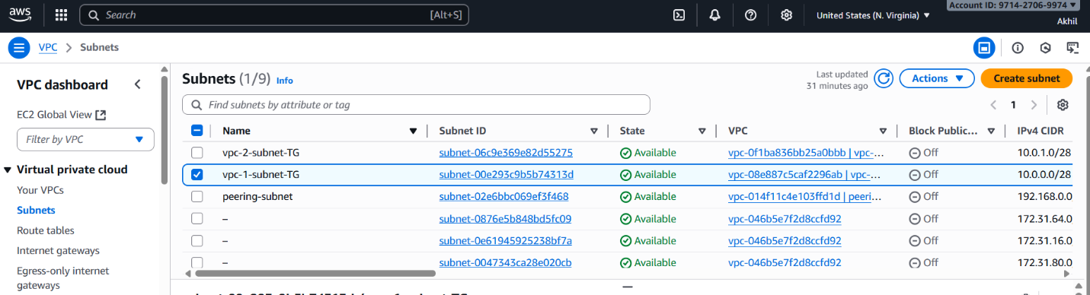

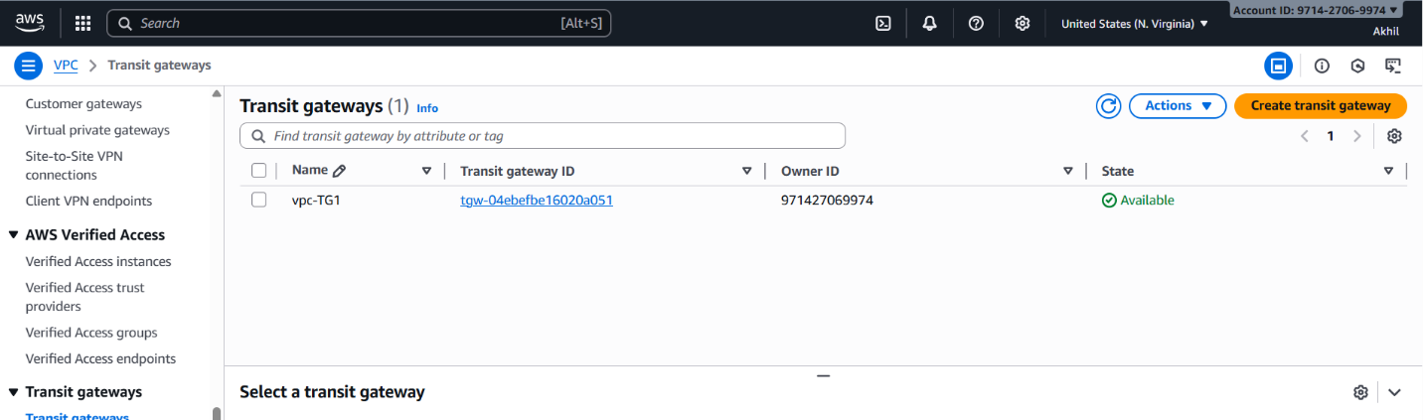
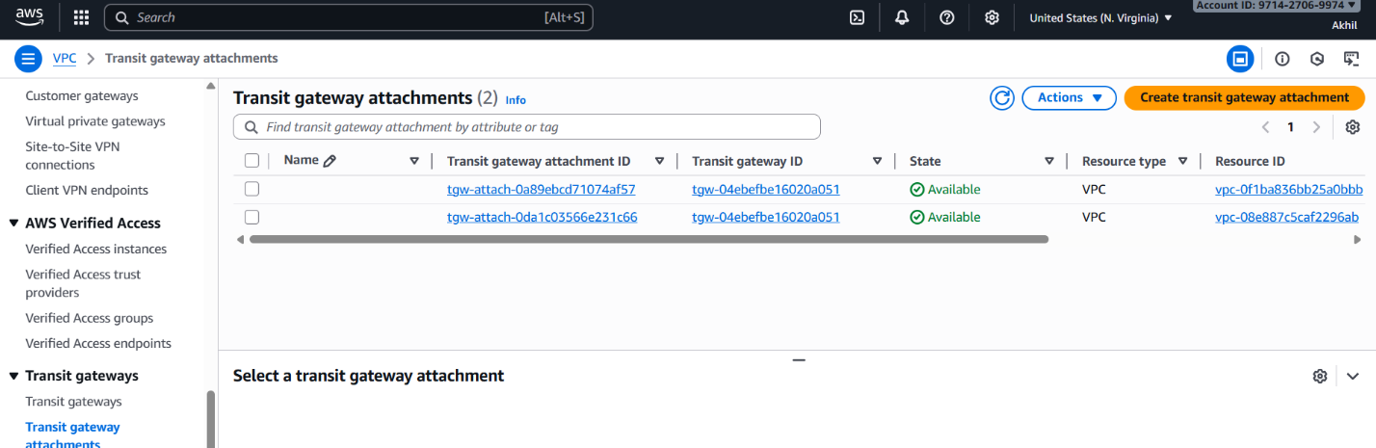

5.Set up a VPC Endpoint.
- Lauch one public and private ec2 instance using private subnet and public subnet
- Create one s3 bucket
- Go to s3 service
- Create s3 bucket the name of the bucket should be unique
- Now connect to public ec2
- Use git bash
- Use ssh command to connect

